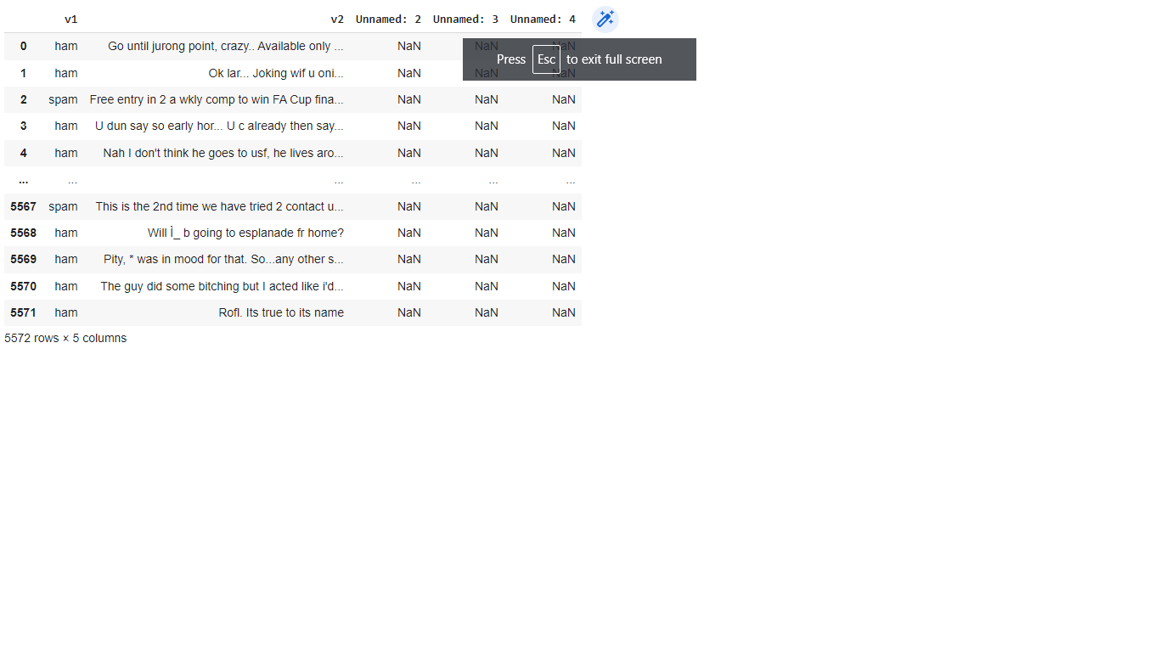

<class 'pandas.core.frame.DataFrame'>

RangeIndex: 5572 entries, 0 to 5571

Data columns (total 5 columns):

# Column Non-Null Count Dtype

--- ------ -------------- -----

0 v1 5572 non-null object

1 v2 5572 non-null object

2 Unnamed: 2 50 non-null object

3 Unnamed: 3 12 non-null object

4 Unnamed: 4 6 non-null object

dtypes: object(5)

memory usage: 217.8+ KB

v1 0

v2 0

Unnamed: 2 5522

Unnamed: 3 5560

Unnamed: 4 5566

dtype: int64

0 Go until jurong point, crazy.. Available only ...

1 Ok lar... Joking wif u oni...

2 Free entry in 2 a wkly comp to win FA Cup fina...

3 U dun say so early hor... U c already then say...

4 Nah I don't think he goes to usf, he lives aro...

...

5567 This is the 2nd time we have tried 2 contact u...

5568 Will Ì_ b going to esplanade fr home?

5569 Pity, * was in mood for that. So...any other s...

5570 The guy did some bitching but I acted like i'd...

5571 Rofl. Its true to its name

Name: v2, Length: 5572, dtype: object

0 ham

1 ham

2 spam

3 ham

4 ham

...

5567 spam

5568 ham

5569 ham

5570 ham

5571 ham

Name: v1, Length: 5572, dtype: object

0 1

1 1

2 0

3 1

4 1

..

5567 0

5568 1

5569 1

5570 1

5571 1

Name: v1, Length: 5572, dtype: int64

1 4825

0 747

Name: v1, dtype: int64

